**Lab 2 – Operators and Variables**

**Using Python Console**

**Ex0**

Find out the values of following expressions using Python console and record your answers.

1. 2 + 6 * 9
2. 43 + 28 / 7
3. 90 + 30 + 40 + 22
4. 30 * 2
5. 50 + 20 * 8 +(3 +6)

**Task 1 – Expressions**

Open PyCharm and Create a Project called Lab 2. In Lab 2 create a Python package task1.

**Ex1**

In task1, create a Python file Ex1.py and write the code below.

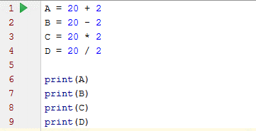

Right click on the window and run your program. You will see the values of A, B, C and D display in the output area.

Verify your answers by running them in Python Console.

**Ex2**

Add a new Python file Ex3.py to package task1.

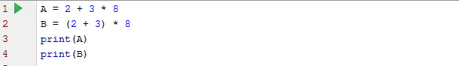

Run above code and find values of A and B. Explain why they are different. Verify your answers by running them in Python Console.

**Task 2 – variables**

**What is a variable?**

Please refer to Week 2 lecture note and (Sweigart 2015) pages 19 -13. Practice examples from the book to understand variables.

In project Lab 2 create a Python package task2.

**Ex1**

In a new python file Ex1.py repeat class exercise in Week 2 lecture note slide 16.

**Ex2**

In a new python file Ex2.py write a program to produce the following output. Code required is similar to Ex 1 above.

Steps:

1. Write an input command with the question “What is your name?”
2. Read the input to a variable – name your variable according to convention.
3. Print by adding the word “Hi” and a space to the variable.



**Ex3**

In a new python file Ex3.py run the following code.

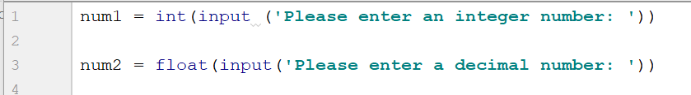

Improve your code to print the sum of the two numbers. Your output should look as follows.

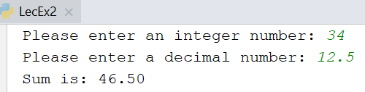

**NOTE:** Use f’ string to format the output. Refer to Topic 2 Appendix.

**Ex4**

In a new python file Ex4.py practice escape sequence examples given in lecture 2 slide 25. Understand the effects of escape characters (\n and \t). You can also do this in Python console.

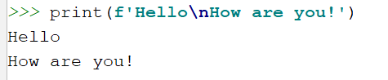

**Ex5**

In a new python file Ex5.py enter and run the following code.

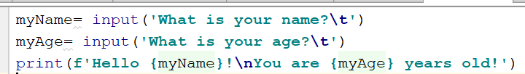

Observe how output is displayed. Update your code to produce the following output.

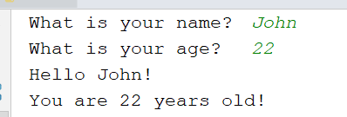

Note: in the input lines there are tab spaces next to the message. And the output appear as two lines due to the \n character.

**Ex6**

In a new python file Ex6.py enter and run the following code.

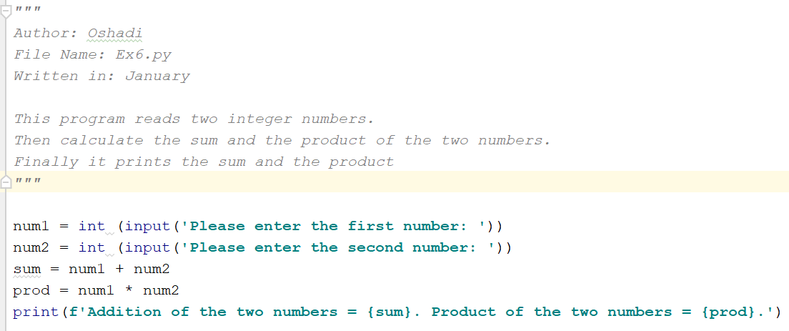

Run and observe the output. Then do the following changes to your code.

1. Add comments before lines 4 and 5 explaining what those lines do.
2. Change your output to print the last output line in two lines.
3. Run above program and try entering numbers 12.5 and 15.8 as the first and second input numbers. What happens? Why? Explain to your teacher.
4. Update your program to read decimal numbers as inputs.

**Ex7**

Write a program to read two decimal numbers as width and the length of a room. Calculate and display the area of the room.

**Additional Exercises**

**Add1**

Write a program tocalculate total purchases at a book store.

The book store sells any new book for $10. Any old book cost $4.50. There are books for renting/borrowing. They cost $2 per day.

For example, if you purchase 2 new books, 1 old book and rented a book for 5 days, your payment should be $34.50.

Design your own interface.

**Add2**

In a restaurant, all take away VEGETARIAN meals cost $11.80. All orders with MEAT (Chicken/ Beef/Lamb) cost $12.80. Any SEAFOOD meal costs $14.00. Write a program to calculate customer order costs.

For example, if a customer orders 2 vegetarian meals and a seafood meal, then the total cost is $37.60.

Design your own interface.

**Add3**

Write a Python program to calculate the cost to lay a concrete slab. Cost of laying concrete is given as $85.00 per square metre.

Details are as follows:

The user will enter the width and the length of the area to lay concrete. Then the program should calculate the area (in square metres).

Area = width * length

Once the area is known, the program can calculate the cost of the concrete laying.

Cost = area * 85.00

Both the area of the slab, and the cost of concreting must be displayed to the user.

**Add 4**

Create a program that asks the user to enter their name and their age. Print out a message addressed to them that tells them the year that they will turn 100 years old.

**Add 5**

Write a Python program to read 3 numbers. One of them should be a decimal value.

Display addition of the numbers with the following formatting (assume user entered 1, 6 and 5.5 as the numbers).

Addition of 3.0 numbers: 12.500

**Add 6**

Write a Python program to read the date, month and year and display the output in following format.

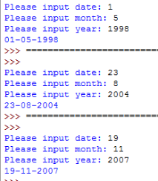

**Add 7**

Create a Python program that will solve the following problem.

Your application should calculate the total cost for paving a given area. Paving is done always with a decorative edge as shown in the diagram.

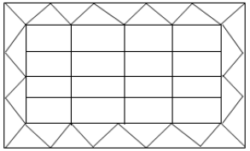

The total tiling cost is calculated as follows:

* Cost for a square meter of straight paving is $100.
* Cost for a square meter of edge paving is $150.

User should provide the following data as inputs (Note: only these 3 datum are required).

* Length of the area to be paved
* Width of the area to be paved
* Width of the decorative edge

Using the input data:

1. Write a formula to calculate the straight paving area.
2. Write a formula to calculate the decorative edge paving area.
3. Write a formula to calculate the total paving area.
4. Use the above formulas in your application to display each area and the paving costs.

Output from 3 sessions are given below.

